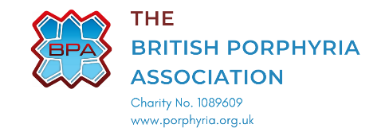
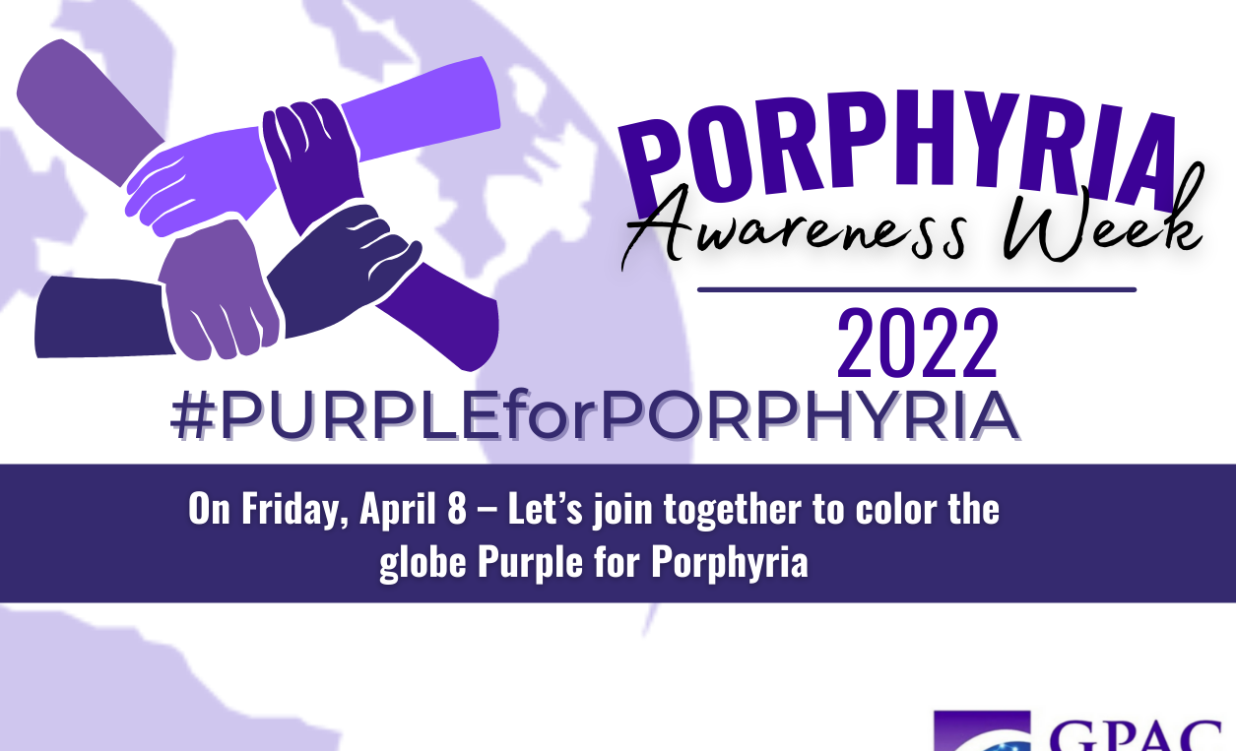

Please join us and

WEAR PURPLE

To raise awareness and funds for the
British Porphyria Association

Contact [your details here] with your kind donations

