Promoting your fundraising on social media
On this page you will find some template social media posts and visual assets (images and videos) you can use to promote your fundraising efforts online.
Please feel free to adapt the posts to your own words – just make sure to tag us in your posts by using the BPA social media handles. The template posts below all use the Twitter handle as example, but it is easy to change this to the relevant handle for the platform you are using, as follows:
Twitter: @BPA_Porphyria
Facebook: @British Porphyria Association Page
Instagram: @british_porphyria_association
Using any of the hashtags shown below can also help to boost the visibility of your posts.
Template posts
- I’m fundraising for @BPA_Porphyria by [insert activity, e.g. running 10K, holding a raffle, etc.] on [insert date]! Follow my fundraising journey and make a donation at [insert link to your JustGiving page]
#PorphyriaTogether #CareForRare #RareDisease #MyPorphyria

- I’m holding a raffle in aid of @BPA_Porphyria – can you help us find some amazing prizes for the lucky winners? Spread the word to your favourite local businesses and help us raise money for #RareDisease today!

#PorphyriaTogether #CareForRare #MyPorphyria

Videos
You can also use the below videos to draw attention to why you are fundraising for the BPA, or record your own video message telling your story in your own words. For example:
- I’m fundraising for @BPA_Porphyria because [insert your reason, e.g. they help families like mine navigate living with a rare disease].
🎥 Watch this video to find out more about how porphyria affects people’s lives: https://youtu.be/QsGt4upaJYw
❤️ Donate to my fundraiser at [insert link to your JustGiving page]!
#PorphyriaTogether #CareForRare #RareDisease #MyPorphyria

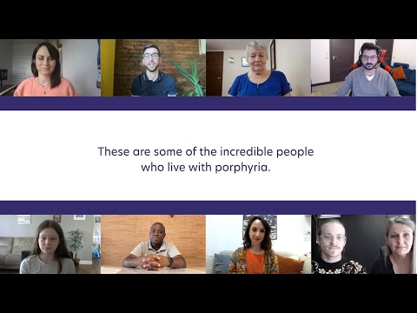

- I’m fundraising for @BPA_Porphyria! Caring donors like you make it possible for the BPA to put on fantastic events like this outdoor activity day for children with EPP, a genetic condition which causes excruciating pain after exposure to sunlight: https://youtu.be/KyIf3leRr8w

Find out more and donate today at [insert link to JustGiving page]

#PorphyriaTogether #CareForRare #RareDisease #MyPorphyria

Note: It is currently not possible to share YouTube videos or any other hyperlinks in Instagram posts. If you would like to share a link on Instagram you can copy it into your profile bio, and if you would like to share the above videos you can do so by sharing them directly from the BPA Instagram page to your stories.

Images
You can save and use these attention-grabbing graphics as part of your posts to promote your fundraising on social media.

Thank you for taking the time to read this page.
We wish you the best of luck with your fundraising efforts!

